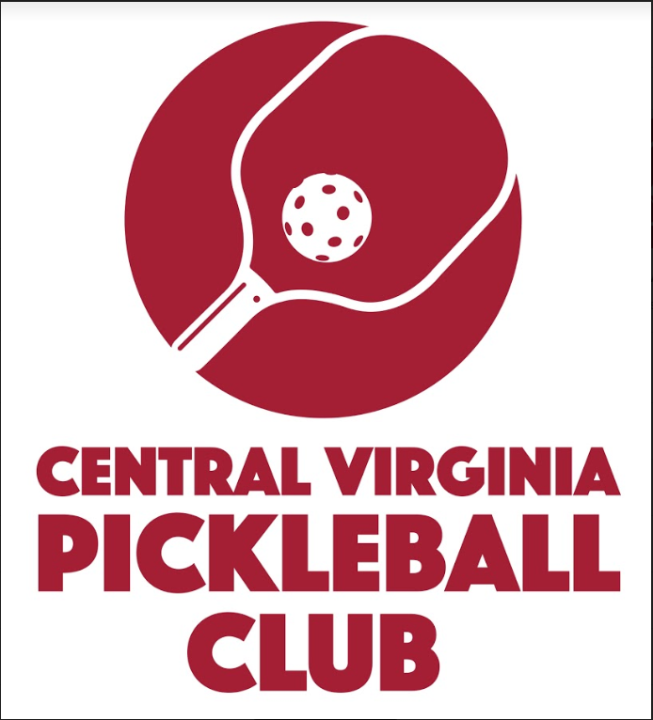
CENTRAL VIRGINIA CUP

INVITATIONAL
Saturday - 6/22/2019 8 AM – 6 PM
Location: Chesterfield Technical Center
13900 Hull Street Road
Midlothian, VA 23112

Charlottesville vs Chesterfield
Yes, that’s right! We are back for another year of the Central Virginia Cup, also known as the CEVA Cup!!
- FOUR skill level divisions – 3.0/3.5/4.0/4.5+
- MENS, WOMENS and MIXED Categories for each Division
- 4 MENS DOUBLES pairings per team for 3.0/3.5/4.0/4.5+
- 4 WOMENS DOUBLES pairings per team for 3.0/3.5/4.0/4.5+
- 4 MIXED DOUBLES pairings per team for 3.0/3.5/4.0/4.5+
- All games will be best 2 out of 3 with games to 11 points
- Up to 16 team points available for each Division
- Total possible points available is 54 (This is the perfect score: TEAM would have to win every match in every Division)
- TEAM with most points wins the PRESTIGIOUS CEVA CUP!
- Cost to play one or two divisions is $27
- You can register today here! Deadline is Saturday, June 15th.

